Report: Machine Learning with Python - Feature Engineering and Model Evaluation

**Morning Session:**

The morning session focused on essential techniques for preparing data and evaluating machine learning models, which are crucial steps in any predictive modeling pipeline.

**Feature Selection, Transformation, and Scaling**

1. **Feature Selection**: The code demonstrated the use of the SelectKBest method from scikit-learn to select the top 4 most relevant features based on the chi-squared test. Feature selection helps reduce dimensionality, remove redundant or irrelevant features, and potentially improve model performance.
2. **Feature Transformation**: The code applied two different scaling techniques to the dataset:
   * **Standard Scaler**: This scales the features to have a mean of zero and a standard deviation of one, which can be beneficial for certain algorithms that assume features are normally distributed.
   * **MinMax Scaler**: This scales the features to a specific range, typically between 0 and 1. This can be useful when dealing with algorithms that are sensitive to the scale of the input features.

Scaling features is often necessary to ensure that all features contribute equally to the model, as some algorithms can be dominated by features with larger numeric ranges.

**Model Evaluation Metrics**

The code evaluated the performance of the logistic regression model using the following metrics:

1. **Accuracy**: The proportion of correct predictions made by the model.
2. **Precision**: The proportion of positive predictions that were correct.
3. **Recall**: The proportion of actual positive instances that were correctly identified.
4. **F1 Score**: The harmonic mean of precision and recall, providing a balanced measure of the model's performance.
5. **ROC-AUC**: The area under the Receiver Operating Characteristic (ROC) curve, which measures the model's ability to distinguish between positive and negative instances.

These metrics provide a comprehensive evaluation of the model's performance, highlighting its strengths and weaknesses in different aspects of classification.

**Afternoon Session:**

In the afternoon session, we used real-world datasets to reinforce the concepts learned in the morning session.

**Feature Engineering Techniques For Machine Learning in Python**

The video lesson covered various feature engineering techniques that can be applied to improve the performance of machine learning models. Some key techniques discussed included:

1. **Handling Missing Data**: Different strategies for dealing with missing values, such as imputation or removal.
2. **Encoding Categorical Variables**: Methods like one-hot encoding and label encoding for transforming categorical variables into a format suitable for machine learning algorithms.
3. **Feature Scaling**: Techniques like standardization and normalization to ensure features are on a similar scale, which can improve the performance of certain algorithms.
4. **Feature Extraction and Selection**: Approaches for reducing the dimensionality of the feature space, such as Principal Component Analysis (PCA) and feature importance-based selection.
5. **Polynomial Features and Interactions**: Creating new features by combining or transforming existing ones, which can capture non-linear relationships in the data.

These techniques are essential for preparing data and extracting meaningful information, which can significantly improve the accuracy and reliability of machine learning models.

**Pima Indians Diabetes Database**

The practical exercise involved working with the Pima Indians Diabetes Database, a real-world dataset commonly used for predicting the onset of diabetes based on various medical attributes.

**Analysis of Model Performance**

The following analyses were performed to evaluate the model:

1. **ROC Curve Analysis:**
   * The ROC Curve plot shows the true positive rate (sensitivity) versus the false positive rate (1-specificity) at various threshold settings. The area under the curve (AUC) indicates how well the model can distinguish between positive and negative classes. In our model, the ROC curve demonstrates good performance with an AUC closer to 1, indicating a high true positive rate and low false positive rate.

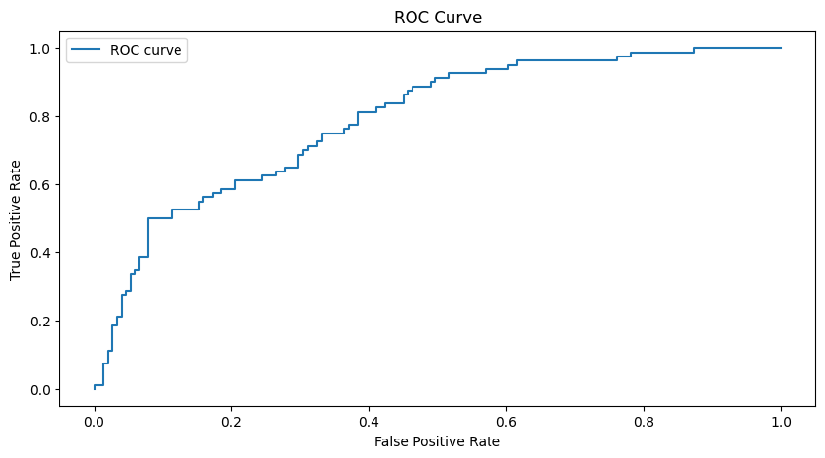

1. **Confusion Matrix Analysis:**
   * The confusion matrix provides a detailed breakdown of the model’s predictions versus the actual labels. In this case, the model correctly predicted 128 true negatives and 43 true positives. However, it also misclassified 23 false positives and 37 false negatives. This analysis helps in understanding the specific types of errors the model is making.

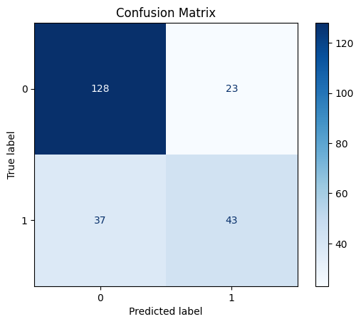

1. **Feature Importance Analysis:**
   * The feature importance bar chart highlights the significance of each feature in predicting the target variable. In this analysis, 'Glucose' and 'BMI' were the most important features, followed by 'Age' and 'Pregnancies'. Understanding feature importance can guide further feature engineering and model refinement.

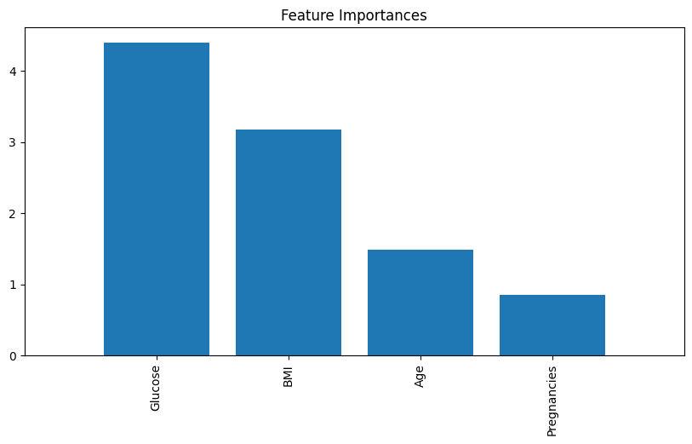

**Conclusion:**

Today’s session provided a comprehensive understanding of feature engineering and model evaluation, equipping me with practical skills to handle real-world datasets effectively. The visualizations, such as the ROC curve, confusion matrix, and feature importance chart, played a crucial role in interpreting the model's performance and making data-driven decisions for model improvement.